Student name :Bhushan samadhan chaudhari
Roll no :18 div :A Batch :1 date:12/11/2025
Practical no.2 hyperlink implementation :add inter and external linka
To an HTML document

input
<!DOCTYPE html>
<head>
<title> About page</title>
</head>
<body>
<h1>About our website</h1>
<p>This is our about page</p>
<p><a href="secondpractical.html"> Back to home page</a></p>
</body>
</html>

Output:
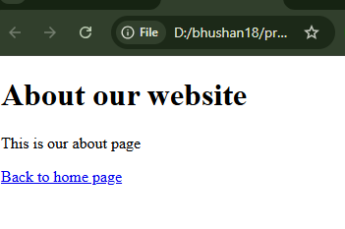

input
<!DOCTYPE html>
<html>
<body>
<h1>Internal Links</h1>
<p><a href="About.html"> Go to About Page</a></p>
<h1>External Links</h1>
<p><a href="https://www.w3sports.com/">Visit w3sporsts.com!</a></p>
<<Body>
</html>
